ME

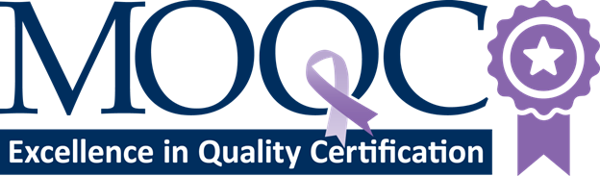
MEQC Closing the Gap Action Plan 2026
[Practice Name]

PLEASE READ THE INSTRUCTIONS BELOW BEFORE COMPLETING your closing the gap ACTION PLAN.
☐ Please submit your Closing the Gap Plan via email to moqc@moqc.org
☐ The Plan must include at least 1 element in each of 3 domains – Data Collection, Interprofessional Education, and Practice. All elements must relate in some way to how your practice will close gaps in care and outcomes.
☐ Data Collection – This should be an improvement in how patient-reported demographic and non-clinical factors will be collected from patients or used at your practice.
- Current State. How are you collecting information from patients in your practice?
- Desired State. How would you like to change what you’re currently doing?
- Action Steps. What changes to the current state need to be made to get to your desired state?
- Examples of changes you might describe
  - Align collection of patient reported non-clinical factors with federal recommendation (Resource: MSHIELD Best Practice Guide)
  - Ensure non-medical factors are collected from patients in a private and confidential way
  - Begin collecting language of care from patients when scheduling first appointment
☐ Interprofessional Education – Please explain how each opportunity will help your practice and your team members close gaps in the quality of care. All MOQC interprofessional development opportunities address gaps in care and thus meet the criteria for educational opportunities. You can find these opportunities at https://moqc.org/development/. Please see the template for additional information required.
☐ Practice – This should be a change that impacts how your office practices care to attempt to close gaps in cancer care and outcomes.
Examples
- Start providing patient materials in patient and caregiver’s language of care
- Become a new YesRx practice
- Ensure all documents are written at a 6th-grade reading level
- Begin screening for unmet non-medical needs
☐ The intent should be to implement the plan within the calendar year.
☐ A new Plan for Closing the Gap needs to be submitted each year and should indicate what progress has been made since the previous year (if applicable)

Closing the gap

Contact Information
Practice Name: Click or tap here to enter text.
Contact Name: Click or tap here to enter text.

Data: Changes in collection & recording of non-clinical patient information
Current State: Click or tap here to enter text.
Future State: Click or tap here to enter text.
Action Steps: Click or tap here to enter text.
Resource: MSHIELD Best Practice Guide

Interprofessional Education
Please include at least one. Feel free to include an attachment with any additional educational opportunities
Educational Opportunity Title: Click or tap here to enter text.
Description (include how the opportunity closes a gap in knowledge or care): Click or tap here to enter text.
Target Audience (Team Members Invited): Click or tap here to enter text.
Planned Date of Completion: Click or tap here to enter text.

Interprofessional Education Continued
Educational Opportunity Title: Click or tap here to enter text.
Description (include how the opportunity relates to closing the gap in knowledge or care): Click or tap here to enter text.
Target Audience (Team Members Invited): Click or tap here to enter text.
Planned Date of Completion: Click or tap here to enter text.

Practice
Please describe at least one change in care that will be made to close a gap in quality of care in your practice. You have unique knowledge of the unmet needs your patients and caregivers face in their daily lives. Provide details regarding the plan to accomplish this change. If you need MOQC to provide resources, please indicate which resources are needed. Please see examples on the instructions page.
Change to be made: Click or tap here to enter text.
Details: Click or tap here to enter text.

Practice Continued
Change to be made: Click or tap here to enter text.
Details: Click or tap here to enter text.

