Reports Guide | 2018


Contents
How to Access Reports 3
Formats available for reports: 5
Reports available for 2018: 5
QOPI® Certification Reports 6
Information provided in the reports 7
Additional information provided in the final reports 8
Medical-Algorithm Based Value 8
Defect‐Free Measures 8
Combined Measures 9
Lower Score‐Better Measures 9

How to Access Reports

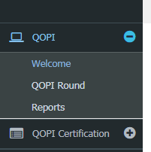
Report links are available on the navigation bar on the left of the page (click QOPI, then click Reports) after logging into the QOPI Dashboard at https://myqopi.asco.org.

In order to see reports you must have “Reports” added to your user role. Only a user who has the user role PRA or PHC can add “Reports” to the user role (PRAs and PHCs can add reports to their own user role as well). To add reports to a user’s account privileges, follow the below instructions:
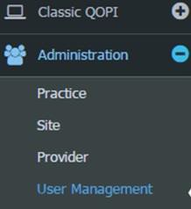

Click on Administration > User Management

Click on the user you want to edit (notice how the “User Role” column only has Data Abstractor – it should also have “Reports”)

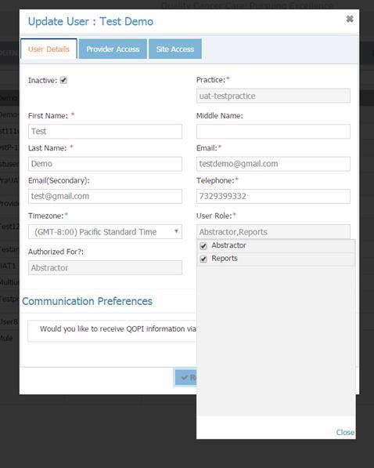
Check reports under “User Role” (not “Authorized For”) so that you have a check mark next to both Abstractor and Reports.

Click Save. Repeat for all users that need to have access to reports.

The PHC and the PRA of an account must also add “Reports” to their own user roles in order to view reports. For the changes to take effect, the PRA/PHC must log out and then log back in to see reports.

Formats Available for Reports:
- XML file with report data
- CSV (comma delimited)
- PDF (least desirable format, high prevalence of associated formatting issues)
- MHTML (Web Archive)
- Excel
- TIFF File (Image File)
- Word

Reports Available for 2018:

REPORT | DESCRIPTION
Chart-Level Detail | This is a highly detailed report that includes practice, site, Chart ID, module inclusion status for each chart submitted (only includes submitted charts) during the round, and coded response values for each captured data field. The coding for each field is available in a separate report – in the dropdown select “Site Trait Code” for the listing of every trait value, code, and meaning.
Chart Status Per Measure | This report can be downloaded during and after the round. It allows you to select from a dropdown of all of the measures in QOPI and then displays all of the charts that met the numerator and denominator of each measure.
Final Certification | Summary report that provides your scores on each of the measures included in the QOPI Certification Program pathway, how your scores compare to other participating sites, the QOPI aggregate, and your overall quality score for QOPI Certification. An email will be sent to opted-in users once the report is available, typically a few weeks after the QOPI round is closed
Frequency | Provides descriptive statistics (frequencies for all elements submitted during collection rounds and percent distributions) of reported charts. Used to check data at ASCO and practice-level.
Graphical Measure Summary Summary | Graphical representation of the Measures Summary Report with images that can be copied and embedded into presentations
Interim Certification | Available approximately 1 week prior to the end of the round. It is a static report that provides your scores on each of the measures included in the QOPI Certification Program Pathway, how your scores compare to other participating sites, the QOPI aggregate, and your overall quality score for QOPI Certification. This report should be used to check if you are on track for your QOPI Certification or Recertification application before the round closes.
Measure Export | Measure numerator, denominator, and rate for each measure reported on for one specific round
Measure Export with Multiple Cycle | Measure numerator, denominator, and rate for each measure reported on, across multiple reporting rounds
Measures Summary | This is a summary file that provides numerator, denominator, and rate for each measure in a particular collection round. This report will provide scores for each measure for the sites under the practice, as well as applicable aggregate scores. For example, if you have multiple participating offices (sites A, B, C), the report will display the scores for Site A, B, and C, as well as the practice aggregate and the QOPI aggregate. Data in this report is color-coded: green percentages indicate that your site scored above the QOPI aggregate, while red percentages indicate your site scored below the QOPI aggregate. The report also includes “Site Affiliation Aggregate,” which corresponds to how the practice identified themselves under the practice demographics (See Administration > Practice > Affiliation tab). The possible site affiliations are Academic Full Time, Private with Academic Affiliation, Employed, Private Independent, and Fellowship Program.
Physician Measure Details | List of measure scores (numerators and denominators) per physician in a practice. Report includes the physicians’ NPI numbers (if they were entered into the QOPI system by the account admin) as well as their associated site(s), if applicable.
Site | The Site report allows the user to view all sites and corresponding program activity associated with the practice.
Site Export | All site-related demographic information can be viewed with this report.
Site Trait Code | Data code dictionary for all data elements. Reference for codes used in the Chart Level Detail report and their meaning in the data per round.
User | Participant information, including contact information, role designated in the system, and the number of charts entered.
User Export | All user information entered for all users within a practice account.

QOPI® Certification Reports
QOPI® provides summary reports that include your practice’s scores on each of the measures included in the QOPI Certification Program Track and your overall quality score for QOPI Certification, as well as how your scores compare to other participating sites and the QOPI aggregate.

INTERIM CERTIFICATION REPORT
- Prior to the close of a collection round, an Interim Certification Report will be released. The interim report provides your site’s preliminary scores on measures required for QOPI Certification for the current collection round, and scoring information should be considered interim until the final QOPI Certification Report for the collection round is released.

FINAL CERTIFICATION REPORT
- Final QOPI Certification reports are available with the release of the QOPI measure reports.

Information provided in the reports

Numerator: Total number of complete charts that met the requirements for the measure (concordant).
Denominator: Total number of complete charts eligible for the measure at the time of the report.

Site Rate: Your site’s score for the measure (numerator divided by denominator).

Percentile: How your site’s score ranks relative to other participating practices. For example, a percentile of 75 would indicate that your site’s score is equal to or better than 75% of the scores achieved by other participating practices.

QOPI Certification Overall Quality Score: Total number of concordant charts divided by total number of eligible charts for the 25 measures.

Additional Information Provided in the Final Reports

QOPI Aggregate: Percentage of charts that are concordant with the measure based on all charts submitted for all practice sites.

Difference from QOPI Aggregate: The difference between your site’s score and the QOPI aggregate. Scores greater than or equal to the QOPI aggregate will display in green text and those below the QOPI aggregate will display as red text.

Determination of eligibility to apply for QOPI Certification: Depending on your site’s Overall Quality Score, you will see one of the two following messages:

Congratulations! Your site has met the requirements for the QOPI Certification measures scoring and is eligible to apply for Certification, provided chart sampling methodology was followed. The application is available at <application link>.

OR

Your site has not met the requirements for QOPI Certification measures scoring and is not eligible to apply for Certification at this time.
Overall Quality Score: An Overall Quality Score of 75% or above is necessary to apply for QOPI Certification

For questions regarding applying for the program, please email qopicertification@asco.org or call the QOPI Certification Help Desk at 571-483-1669.

Medical-Algorithm Based Value

Defect‐Free Measures

- A defect-free measure is one in which a chart must have met the criteria for all measures for which it applies. There are several defect-free measures that originated in the Spring 2010 round, including:
Core 6 - Pain addressed appropriately (defect-free measure, 3, 4a, and 5)*
Core 6d - Pain addressed appropriately on either of the two most recent office visits (defect- free measure, 6a, 6b, and 6c)
Core 6e - Pain addressed appropriately by second office visit and during most recent office visits (defect-free measure, 6 and 6d)
Core 13 - Chemotherapy planning completed appropriately (defect-free measure, 9, 10, and 12)
Core 13a1 – Chemotherapy administered to patients with metastatic solid tumor with performance status of 3, 4, or undocumented (effect-free measure, 13a1a, 13a1b)
Core 13oc4 - Documented plan for oral chemotherapy (defect-free measure, 13oc4a-
13c4d) (Test Measure)
Core 13oc5 - Oral chemotherapy education provided prior to the start of therapy (defect-free measure, 13oc5a-13oc5c)
Core 13oc6 - Oral chemotherapy monitored on visit/contact following start of therapy (defect-free Measure, 13oc6a-13oc6b) (Test Measure)
Core 20 - Chemotherapy summary process completed within 3 months of chemotherapy end (defect-free measure, 17, 18, and 19)
Core 23aa - Smoking/tobacco use cessation administered appropriately in past year (defect- free measure, 21aa, 22aa, and 22bb)
Symptom/Toxicity 29 - Anti-emetics prescribed appropriately with moderate/high emetic risk chemotherapy (defect-free measure, 27 and 28)
EOL 38 - Pain assessed appropriately (defect-free measure, 35, 36a, and 37)
EOL 41 - Dyspnea addressed appropriately (defect-free measure, 39 and 40)
EOL 44a - Hospice enrollment and enrolled more than 3 days before death (defect-free measure, 42 and inverse 44)
EOL 45a - Hospice enrollment and enrolled more than 7 days before death (defect-free measure, 42 and inverse 45)
Breast 49 - Complete family history documented for patients with invasive breast cancer (defect-free measure, 49a-49c)
CRC 63 - Complete family history documented for patients with invasive colorectal cancer (defect-free measure, 63a-63c)
CRC 65 - Genetic testing addressed appropriately for patients with invasive colorectal cancer (defect-free measure, 65a-65c)

*Measures are also part of QOPI Certification

Combined Measures
- There are two combined measures in the round.
Core 16 - Patient consent for chemotherapy (combined measure, 14 or 15)
EOL 47 - Hospice enrollment, palliative care referral, or documented discussion (combined measure, 43 or 46)
- For a chart to be considered concordant in a combined measure, criteria for either must be met. For example, for Core 16 - Patient consent for chemotherapy (combined measure, 14 or 15), if there is either a signed consent in the chart or there is a practitioner’s notation that the patient consented for chemotherapy, the chart counts as “passing” the measure.

Lower Score‐Better Measures
There are several measured labeled as Lower Score – Better for the Spring Round. Please see QOPI® User Manual for list of measures or visit the public QOPI® website. These measures assess overuse (or late administration of services in the case of hospice enrollment) and therefore a lower score in the measure demonstrates better performance/concordance.

